Task no 3



Microprocessor Based System Design

Spring 2022

Submitted by

**Name Registration no**

Muhammad Ali 19pwse1801

Submitted to: **Dr Bilal Habib**

Department of Computer System Engineering

**Code: -**

#incountlude <reg51.h> #incountlude <stdio.h> sbit pin1 = P1^1; sbit PIN2= P1^2; int COUNT = 0; unsigned int CHANGE = 0; void start_timer0(void){

TR0 = 1;

}

void timer0 (void) interrupt 1

{

if(COUNT==0)

{

if(pin1==0 && CHANGE==0)

{

pin1=1;

TH0 = 0xD8;

TL0 = 0xEF;

}

else {

CHANGE++;

pin1=0; if(CHANGE==9)

{

CHANGE=0;

}

TH0 = 0xD8;

TL0 = 0xEF;

}

}

else if(COUNT==1)

{

if(pin1==1)

{

TH0 = 0x63;

TL0 = 0xBF;

}

else {

TH0 = 0xD8;

TL0 = 0xEF;

}

pin1 = ~pin1;

}

else if(COUNT==2)

{

if(pin1==1)

{

TH0 = 0xC5;

TL0 = 0x67;

}

else {

TH0 = 0xD8;

TL0 = 0xEF;

}

pin1 = ~pin1;

}

else if(COUNT==3)

{

if(pin1==1)

{

TH0 = 0xF6;

TL0 = 0x3B;

}

else

{

TH0 = 0xD8;

TL0 = 0xEF;

}

pin1=~pin1;

}

}

void init_timer0(void){

TMOD = 0x01;

TH0 = 0xFB;

TL0 = 0x9A;

IE = 0x83;

}

void main(void)

{

init_timer0(); start_timer0(); while (1)

{

if(PIN2==0){ if(COUNT < 3) COUNT++; else if(COUNT==3)

COUNT=0;

}

}

}

**First time press button: -**

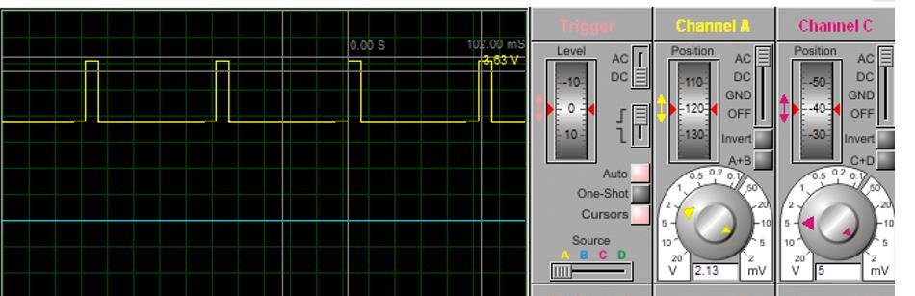 **second time press button: -**

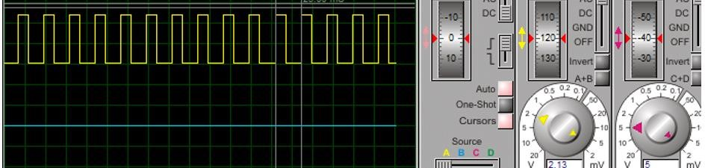

**Third time press button: -**

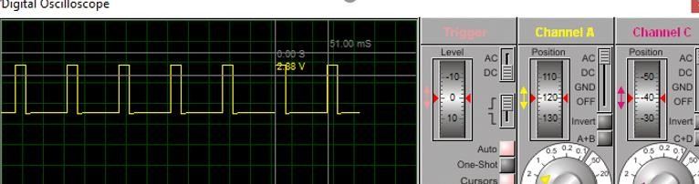

**Schematic: -**

